WSTAR Data center infrastructure plan

# The location of the data center

The data center research infrastructure will be located in Technobothnia, which is co-owned research and education laboratorio of higher education institutes of Vaasa. The location of the data center in [Technobothnia](https://www.technobothnia.fi/) is marked with red color in the following figure:

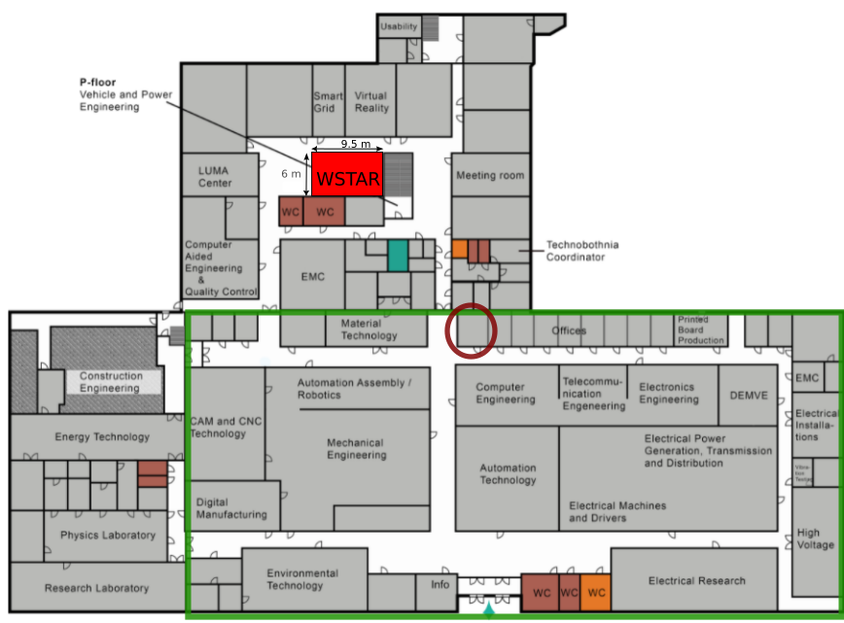Figure 1: The floorplan of Technobothnia, and the planned location of Wstar research infrastructure marked as red

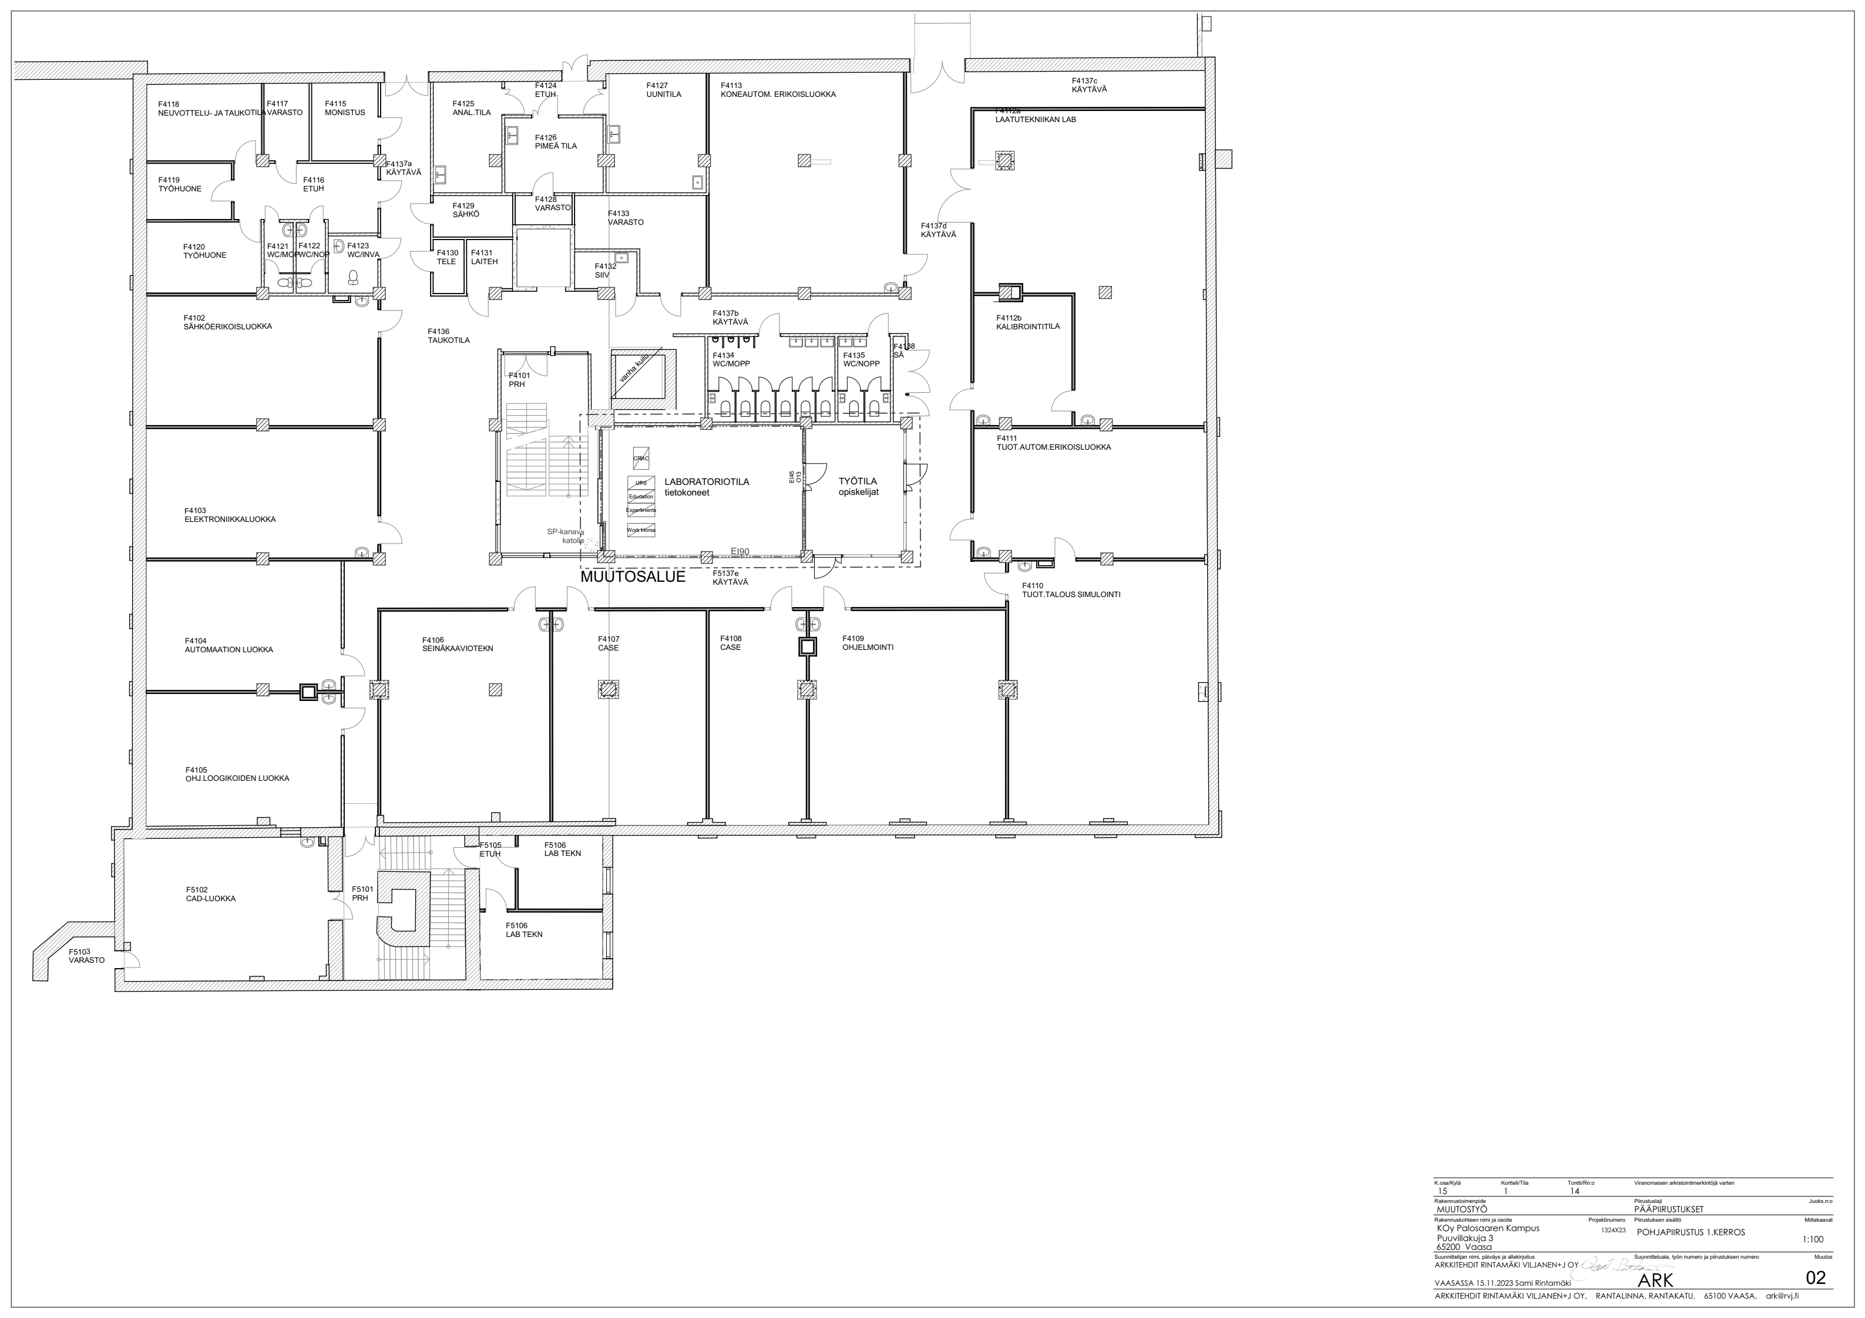Figure 2: The floorplan of the planned data center research infra in TB, shown as “Laboratoriotila” + “Työtila” in the middle located in the first floor of TB. Notice that the figure is upside down, compared to Figure 1

# Requirements of the Wstar research infrastructure

## AI hardware

AI is becoming more important load for data centers and the energy consumption of the AI is becoming a problem. See ([Generative AI’s environmental costs are soaring — and mostly secret](https://www.nature.com/articles/d41586-024-00478-x)).

The AMD’s TPUs may still lack SW support, and therefore it is better to concentrate on NVIDIA and CPU based calculation at the moment. Ampere’s, ARM-based Altra CPU:s could be also interesting, since they claim to be suitable for energy efficient HW. To get understanding of the available budget and computing power, an example configuration is collected in Table 1. This example configuration indicates that we will need to reserve approximately 200 k€ for computing HW including the VAT. The prices are very hard to get, and may be inaccurate. We can ask quotes when the the final configuration is ready.

Table 1: Suitable server hardware (just an example configuration)

|  |  |  |  |  |  |
| --- | --- | --- | --- | --- | --- |
| **Component** | **TPD / kW** | **Price / €, VAT 0%** | **Number** | **Combined TPD** | **Combined price** |
| [Gigabyte H262-ZL0](https://www.gigabyte.com/Enterprise/GPU-Server/G262-ZL0-rev-G00), Dual AMD EPYC, bare bone + CPUS + HD + RAM (Liquid cooled) | 2,2 | 10 k€ | 4 | 11 | 40 k€ |
| Dell poweredge R650 (Liquid cooled) | 1,0 | 6 k€ | 4 | 5 | 24 k€ |
| Gigabyte G242-P35, HPC/AI Arm Server - Ampere® Altra (Air cooled) | 1.6 | 12 k€ | 2 | 3 | 24 k€ |
| [Supermicro H13](https://www.supermicro.com/datasheet/datasheet_H13_Hyper-U.pdf) Single-Socket AS -1115HS-TNR (Air cooled) | 1,2 | 6 k€ | 4 | 4,8 | 24 k€ |
| Nvidia Hopper H100 | 0.3 | 57 k€ | 0 |  |  |
| Nvidia Ampere A30 | 0.2 | 8.5 k€ | 4 | 1 | 34 k€ |
| [Nvidia L4](https://www.nvidia.com/en-us/data-center/l4/) TPU | 0.1 | 4.2 k€ | 4 | 0.5 | 17 k€ |
| **Total** |  |  |  | 25 | 180 k€ |

We will equip the education rack with donated air-cooled servers, and do not reserve funds for purchasing them.

We will install some of the servers to the experimental rack, as needed. The experimental rack can be air cooled, and will probably only include a small amount of computing power.

The routers and some additional IT infra is not included in the above calculations. They needs to be added.

## Heat management and reuse:

The big data centers need a big heat consumer to reuse the heat. Priming the heat with a heat pump to the district heating system is a mainstream method for new data centers, requiring about 70 degrees temperature. We can use the same in our research infrastructure to deliver the heat to the Tecnobothia building. Even though Technobothnia currently uses high feed-in temperatures directly from the district heating, as shown in Figure 5, it can also probably do with lower temperatures, as explained by Tammi kiinteistöt (ask for details from Juhani Tammi). Therefore, it may be possible to do also without a heat pump by increasing the cooling water temperature using a suitable liquid cooling solution. Liquid cooling would also improve the efficiency of heat reuse with a heat pump-based heat recovery solution.

The heat pump-based solution is acceptable if no other method can reach the needed supply temperature. The heat recovery system should also be configurable, allowing us to optimize the cooling water temperature and flow for maximum energy efficiency and to connect various cooling systems to it later. Some 20-30% of heat that cannot be removed using liquid cooling requires still air cooling. Rear door cooling would be favorable because it saves space and provides higher water temperature. The low-power education rack does not have special requirements, and it can be cooled solely by air.

## Batteries and power supply

* Bi-Directional UPS to support provision of grid services
* New battery Chemistry: Li-Ion, Na-I, LFP

400 VDC, for now. But also AC power will be needed to some devices like circulating pumps.

Capacity to install large set of batteries in the Teletila in the future. Li-Ion phosphate batteries now, and rediness for Na-I batteries in the future. 100€/kWh. Fire safety requirements needs to be checked and fulfilled.

## Measurements

* Power monitoring of each server is needed.
* Water temperature and flow sensors for on-chip cooling pipeline. Server specific heat flow measurement would be great.
* Server temperature measurements from the server components are needed, and probably provided my most of the servers. Some sensors can be added later on.
* Some air temperature sensors can be added to the system.

## Experiments

Some concrete experiments that we would like to carry out during the Spring 2025 would include.

* Testing the on-chip cooling with different input and output water temperatures, searching for optimal efficiency.
* Installing and comparing different generative AI models, and running various tasks with different models and comparing their energy consumption
* Running VR processing tasks, such as point-cloud to surfaces processing to estimate efficiency and power consumption with different hardware. We could create a VR model of the data center research infrastructure at the same time, so we need also the drawings in the digital form (IFC/BIM model)
* Measuring the losses in the power supply line, and the performance of the batteries. Also state of health measurements made by another project will be included.

## Contacts

We have already discussed with many companies about different data center topics. It may be efficient to reach these persons, because they already know about our project. We also favor collaborators who would be interested in having future research collaboration with us

* Power supply, power converters and UPSs:
  + Stefan Strandberg and Olli-Pekka Aalto / Danfoss Drives, Vaasa
  + Merve Özcan and Jyrki Leppänen / EPC Power Oy, Vantaa
* On-Chip cooling
  + On-chip 1-phase cooling: Nvent (Marcus Gerber, Ulf Broome), represented by Orbis (Heikki Saukko). Another provider is a startup Arctic Impulse (Jussi Kakkonen). Even though Arctic Impulse is still a small company, the possible research collaboration opportunities are attractive.
  + On-chip 2-phase cooling: Zutacore (Nikolai Filev and Inbar Reshef) represented by Nextron (Thomas Kappfjell). Also from Arctic Impulse (Jussi Kakkonen)
* Batteries: Personal contacts by Johan Dams from our team.
* All components
  + Rittal (Timo Lebeitsuk, Mikko Aho)
  + Schneider Electric (Anssi Litmanen)

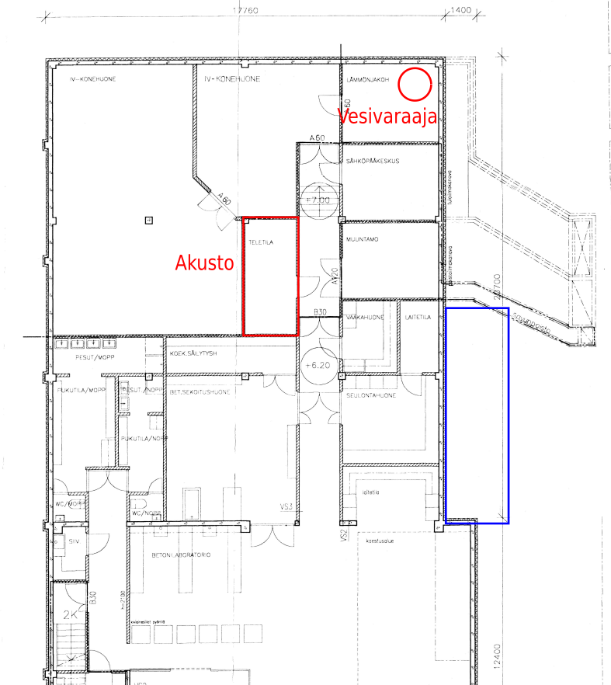Figure 3: The location of battery room "Akusto" and the facility heating management room "Lämmönjakohuone" in the cellar of the Technobothnia

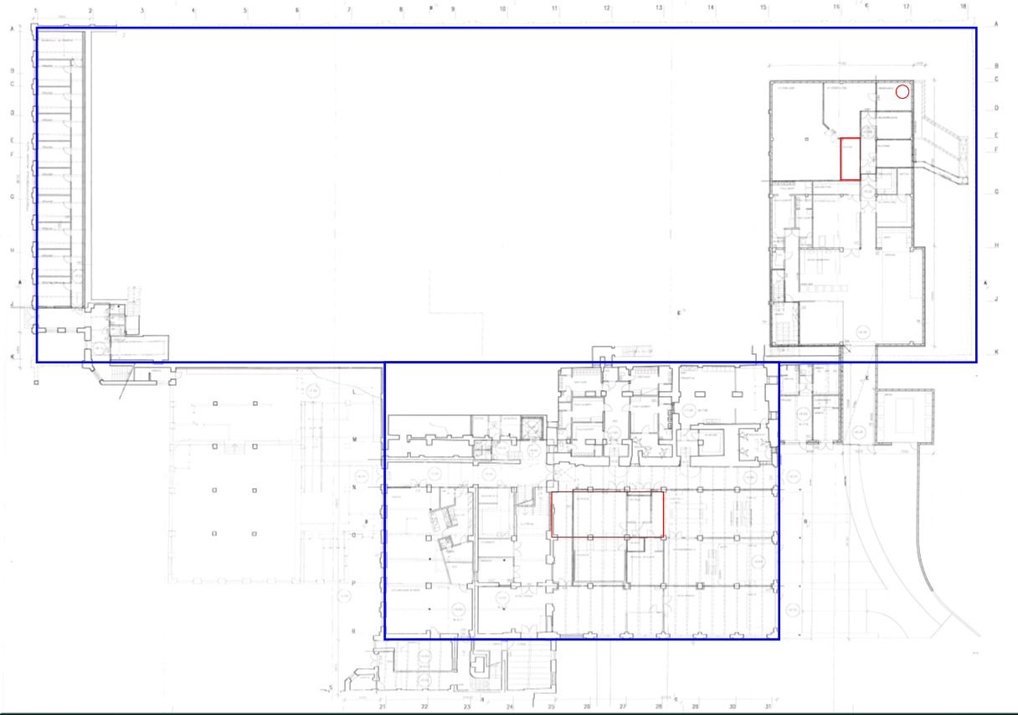Figure 4: The floorplan image containing relevant parts from the cellar and floor 1 in the same picture.

Figure 6: All floors in the same figure. The DC research infra in the bottom middle, the batteries and facility heat management in the top right.

Figure 5: The inflow and return temperatures of the Technobothnia heating facility from the district heating network in year 2021.

Figure 7: The heat energy consumed by TB in 2021 in kWh/h.